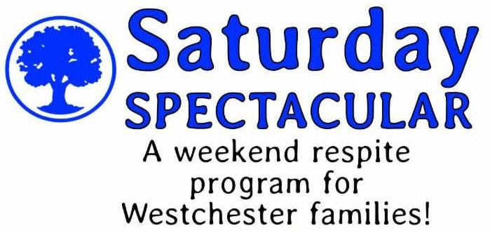

Hawthorne's Saturday Spectacular program is designed as a respite opportunity for Westchester parents. The program is a fantastic chance to give Westchester families a well-earned break on a Saturday afternoon, twice each month. Hawthorne's Saturday Spectacular offers three hours of leisure and recreational opportunities including, music, art, swim and social activities. All activities are coordinated by a NYS certified special education teacher with extensive ABA experience. Your child will love it, and you will love it too!

When: | Saturday - Twice a month  11am - 2pm
Where: | Hawthorne Country Day School  Westchester Campus  5 Bradhurst Avenue  Hawthorne, NY
Who May Attend: | Westchester residents, up to age 21,  who meet OPWDD eligibility  For more information on OPWDD eligibility,  visit their Front Door website.  It's easy and very helpful!
Space is limited. Reserve your spot now.
For more information please call or write
Nicole Prisco
914-592-8526, ext. 2111
nicolecp@hawthornecountryday.org

